**EVENTS APP**



**User manual**

**Install from here:**

<http://10.1.1.19/~2015csb1021/events.apk>

**Provide Feedback here:**

<https://goo.gl/O4wpGg>

**Login/Register:**

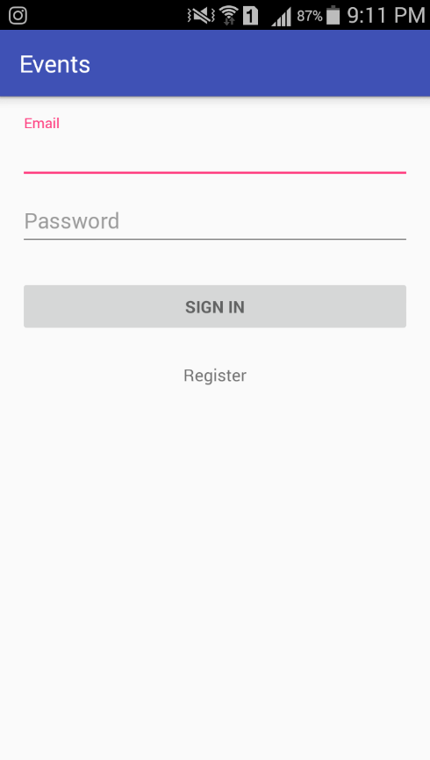After Installation open the app. The first page is the Login-Activity.

Existing user can enter his/her email and password to SIGN IN.

Being first time user. Click on Register button.

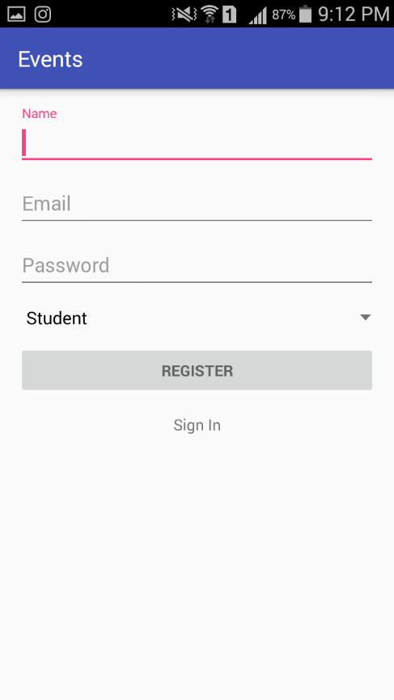After clicking on Register button, new activity opens.

Enter your Name, Email and Password.

(Email should be of type <xyz>@iitrpr.ac.in).

Password should be at least 8 characters long.

Choose your category.

Click on REGISTER.

Message appears declaring successful registration.

After this you are directed to the Login-Activity.

Now enter your credentials and click SIGN IN.

**List Events:**

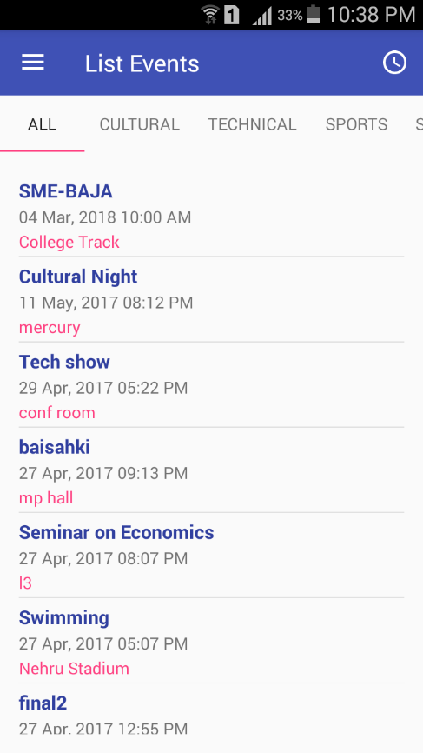This Activity contains the list of all events which are visible* to user.

Also the events are listed according to their types* as well.

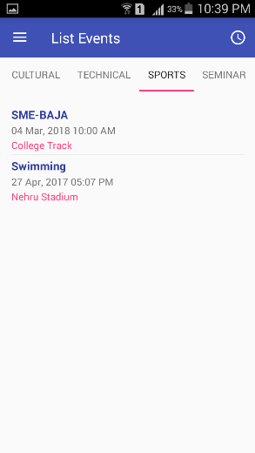 Cultural: Technical: Sports:

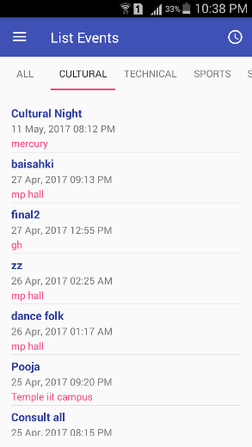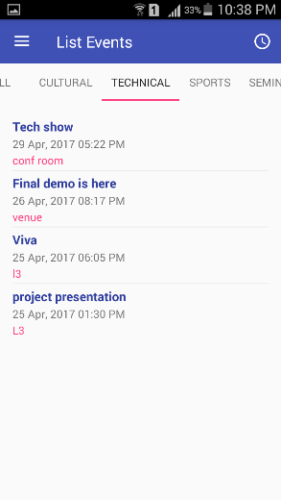

Click on any event you are interested in: for instance

*‘Cultural Night’*

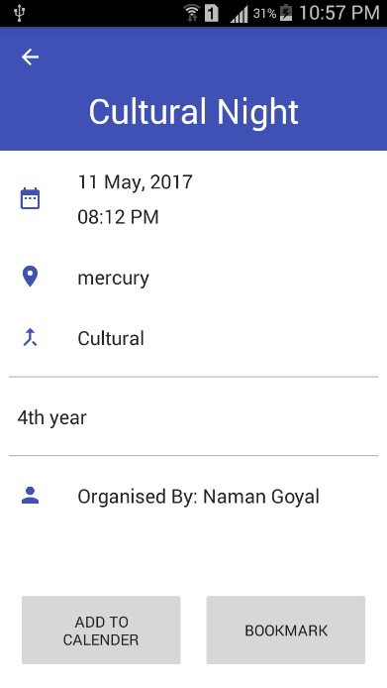This activity displays the necessary info related to the event.

You can *‘BOOKMARK’* this and get this event enlisted as your bookmarks, so you can later on decide what to do.

Or you can ‘*ADD TO CALENDER’* this would set a reminder on your device.

*(* explained later).*

*‘ADD TO CALENDAR’* looks for any calendar app installed in the device.

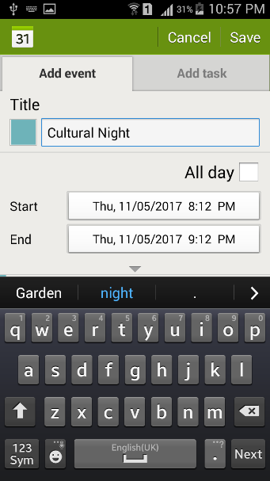There the user can add events to his calendar, and save his event.

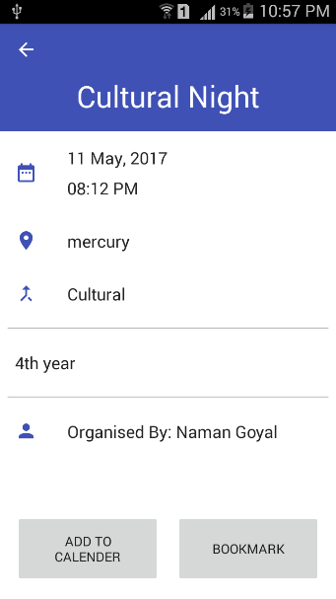

Navigation Bar:

**Click here this opens this *Nav-bar*.**

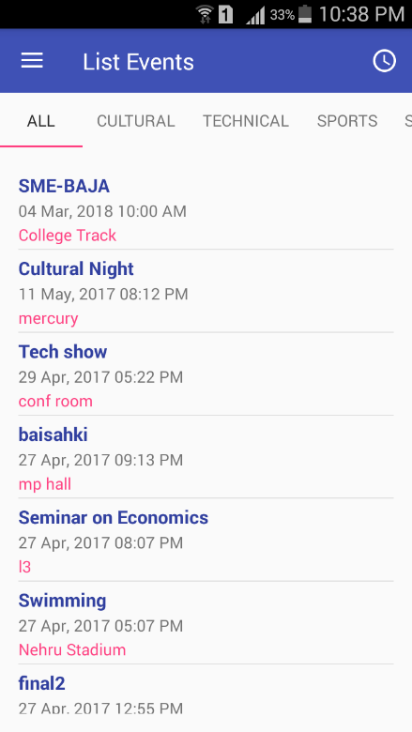

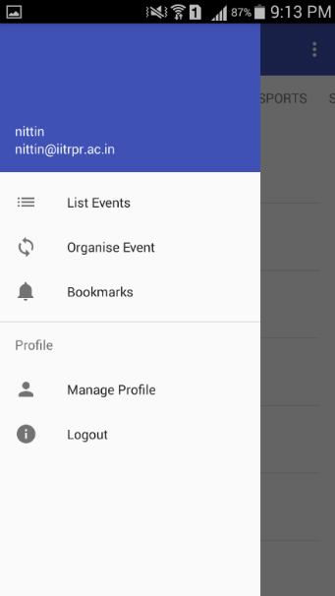

**Click here for List of past Events.**

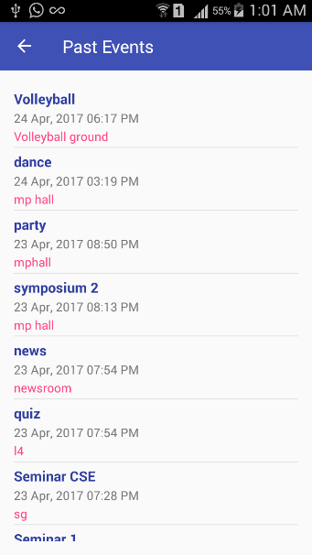

**Navigation Bar (Nav-Bar):**

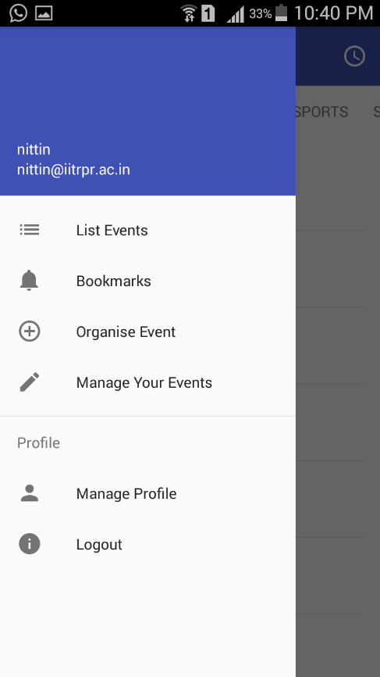

This button redirects you to the *List-all* activity.

This button takes you to the Organise Event Activity.

This button takes you to list of all bookmarks you have created.

This button helps in making any changes to Events that you have organised.

This button takes user to his/her profile

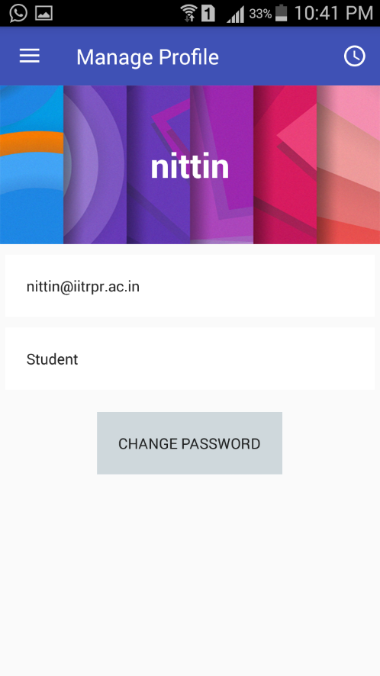

User can change his/her password.

This button logs out the user, the user is directed to the login-activity.

**Organise Event:**

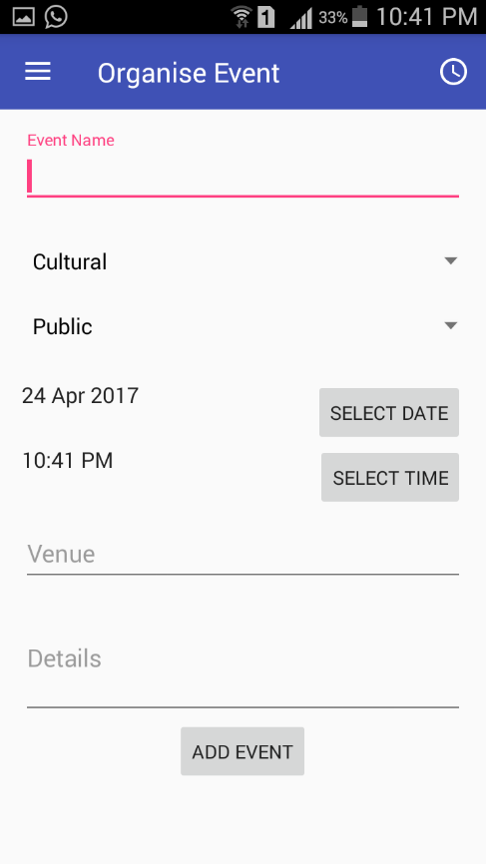This activity opens on clicking the Organise Event Button.

The user can add/create event of his/her own interest.

Category/type can be chosen from the options.

Next step is to decide the visibility of events:

Public 🡪 visible to all.

Rest 🡪 Visible only to that category.

Date and Time should be of future, or else it won’t be displayed on the list.

Venue and Details should be provided by organiser.

Click on ‘ADD-EVENT’. For instance, consider an event ‘ISMP Meeting’ being created.

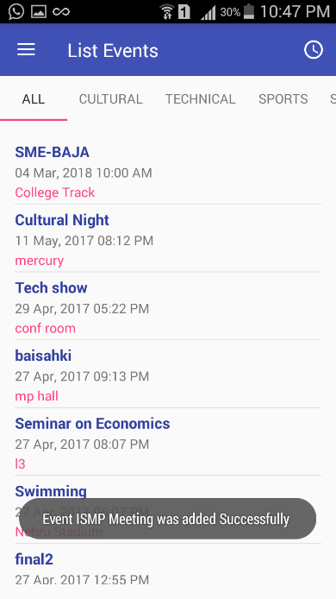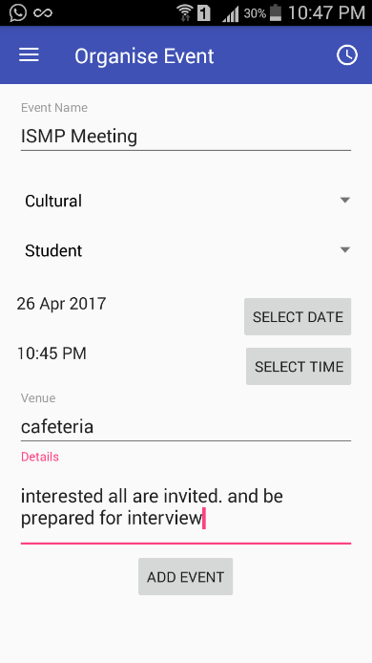

This creation of new event sends a notification to all the concerned.

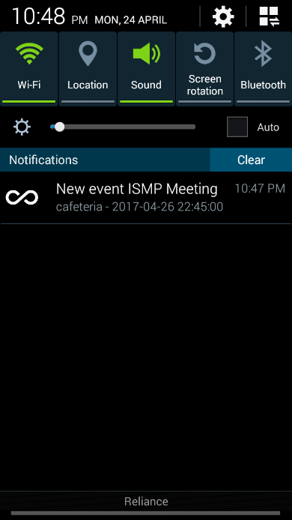Click on the notification. It opens the event and gives option of bookmarking or adding to the calendar.

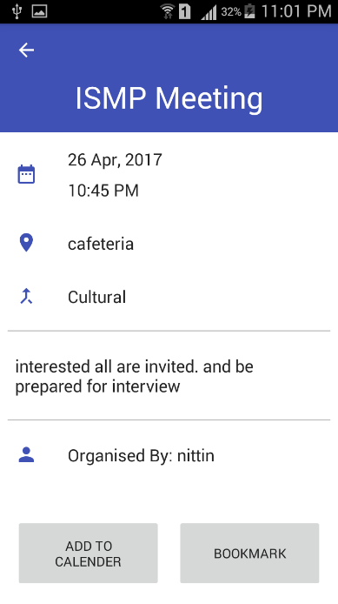

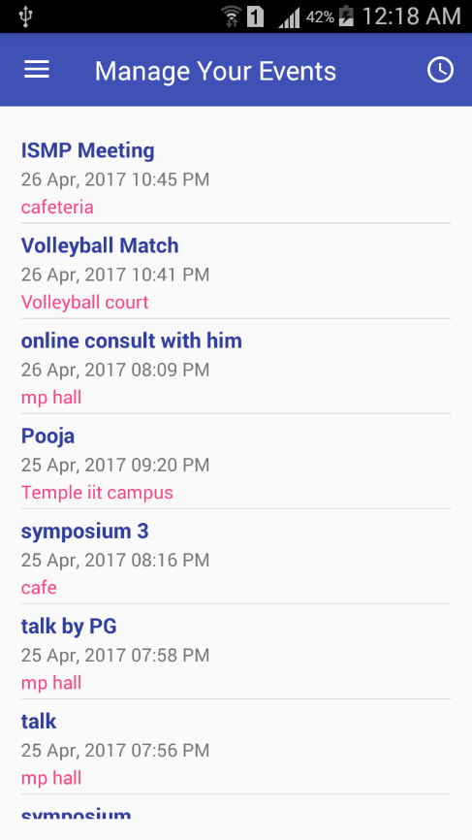 **Manage Your Events:**

Click on:

*‘Manage Your Events’*

This displays all the events you have organised till now.

Choose whichever event you want to Edit; Suppose we want to change details of ‘Pooja’; Click on ‘Pooja’:

This opens the Edit Organised Event Activity:

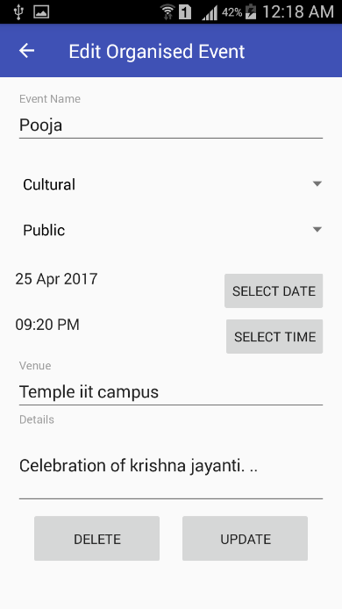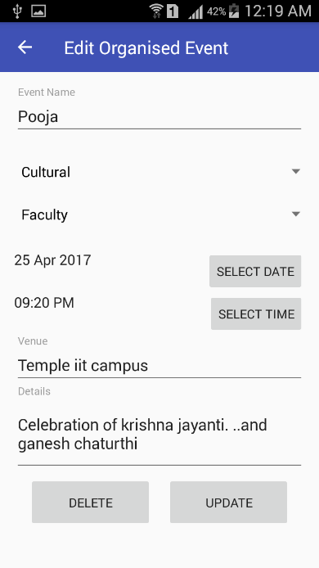Make necessary changes.

As shown:

Click on *‘UPDATE’* button, this updates all the changes you have made and a notification is sent to all the concerned.

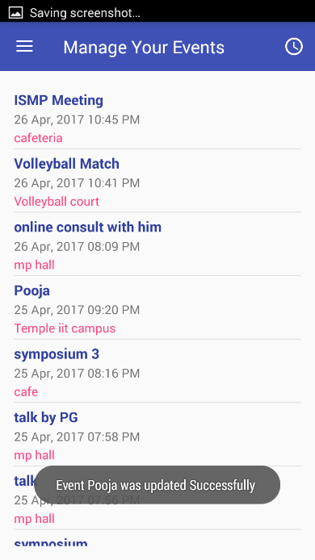

**Delete:**

In case the organiser wants to delete his/her organised event. He/She can simply go to the Edit Organised Event activity and Click ‘DELETE’.

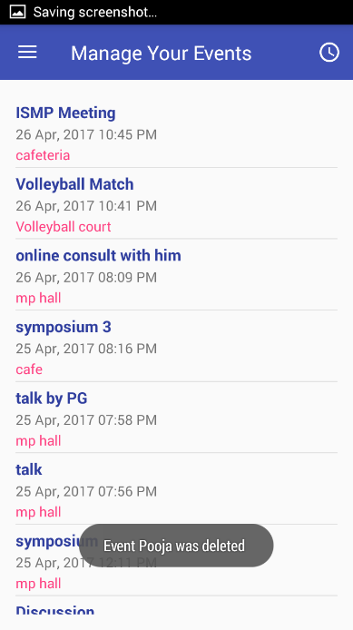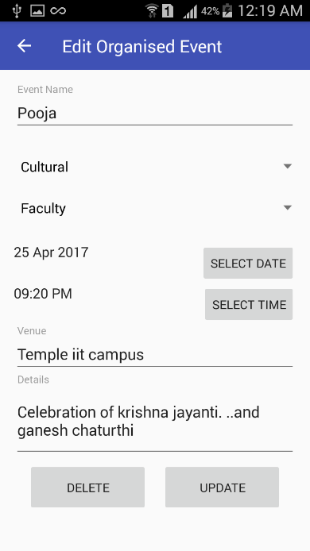

Click On ‘DELETE’

and the event is permanently deleted.

“The App thus provides an easy solution for creating events and notifying all concerned.” 😊